Self-Healing Infrastructure with Prometheus, Alertmanager & Ansible

**Overview of the servers:**

| **Server** | **Purpose** | **Components Installed** | **Example Hostname** |
| --- | --- | --- | --- |
| **Server 1** | Monitoring Server | Prometheus + Alertmanager | monitor-server |
| **Server 2** | Application Server | NGINX (sample service to monitor) + Node Exporter | app-server |
| **Server 3** | Automation Server | Ansible (will receive webhook from Alertmanager) | ansible-server |

Step 1: Launching 3 servers

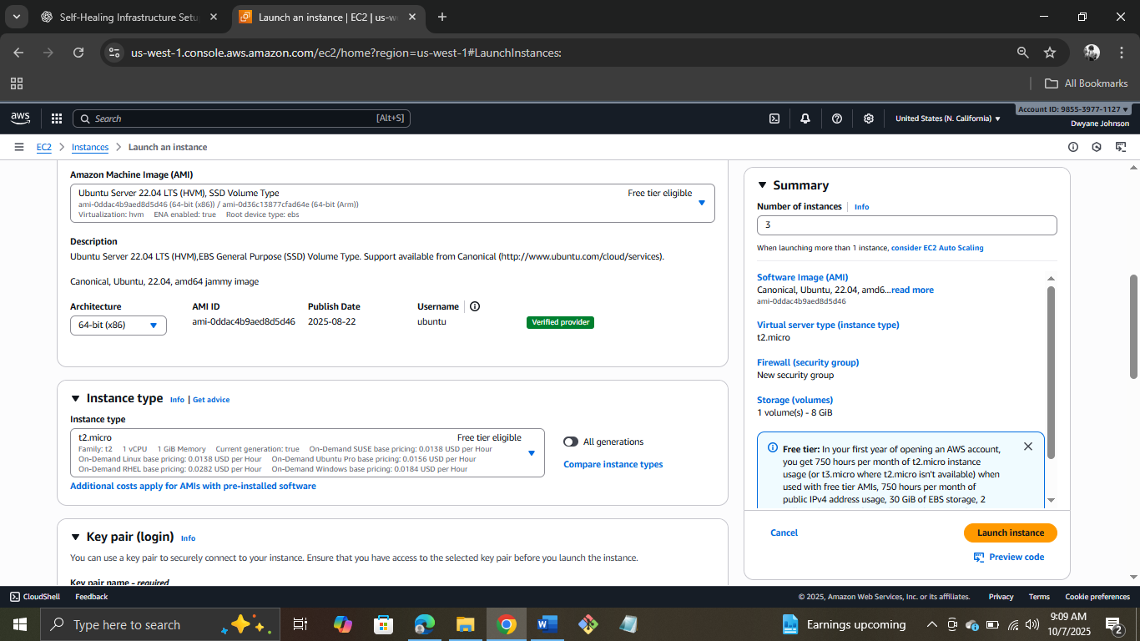

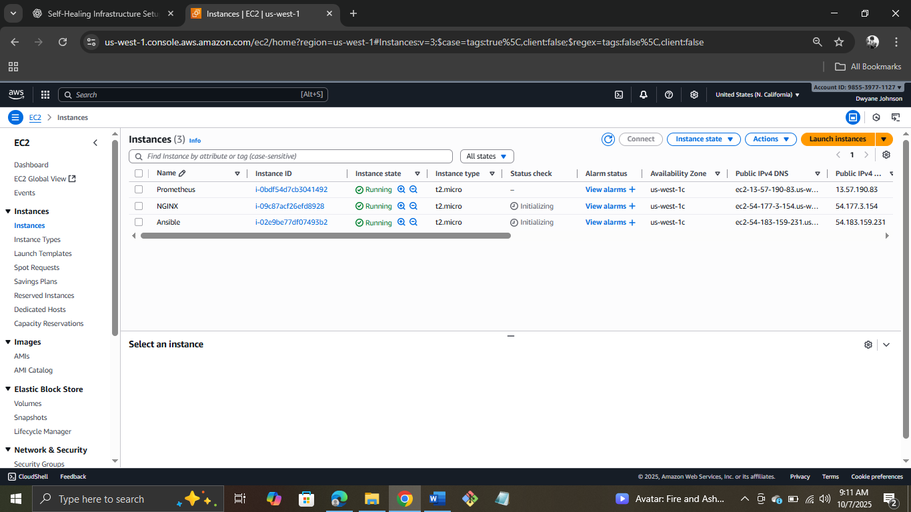

Step 2: Connecting NGINX server to git bash and Installing NGINX and Node Exporter

Installing NGINX



Installing NodeExporter

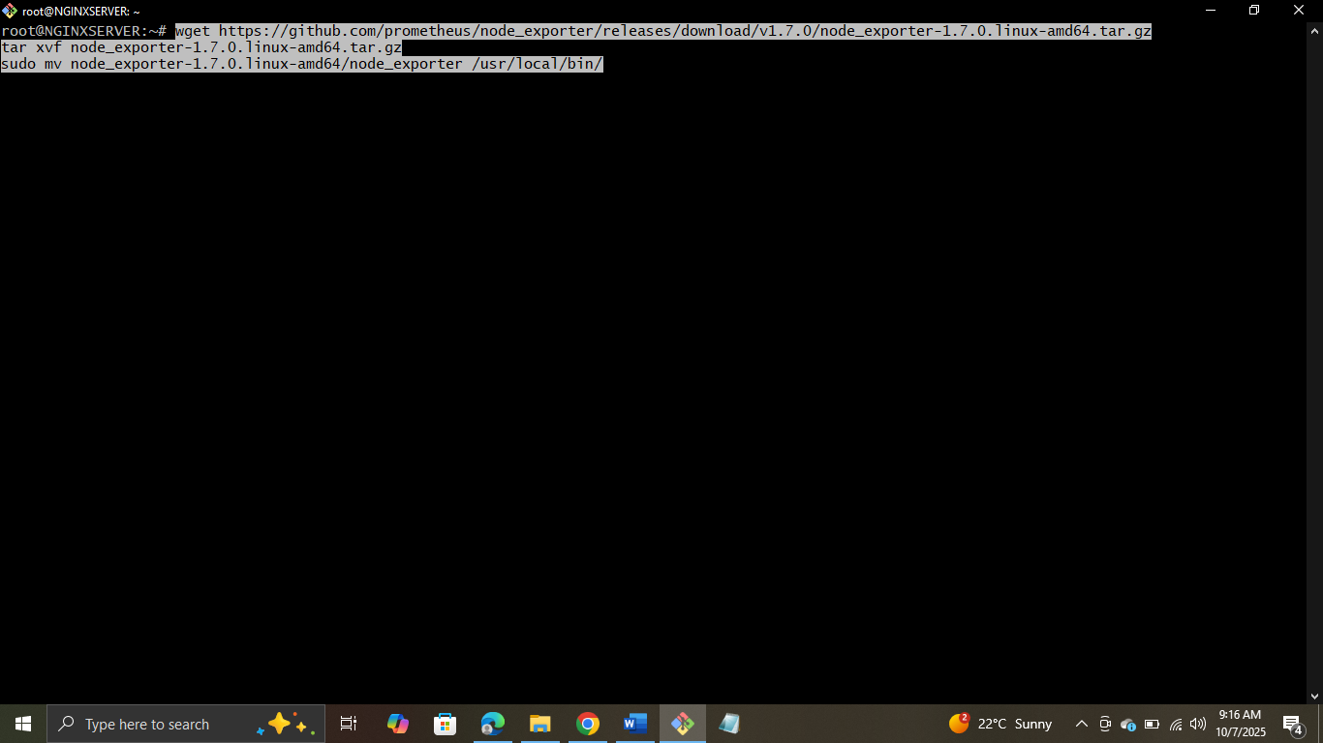

Creating system service

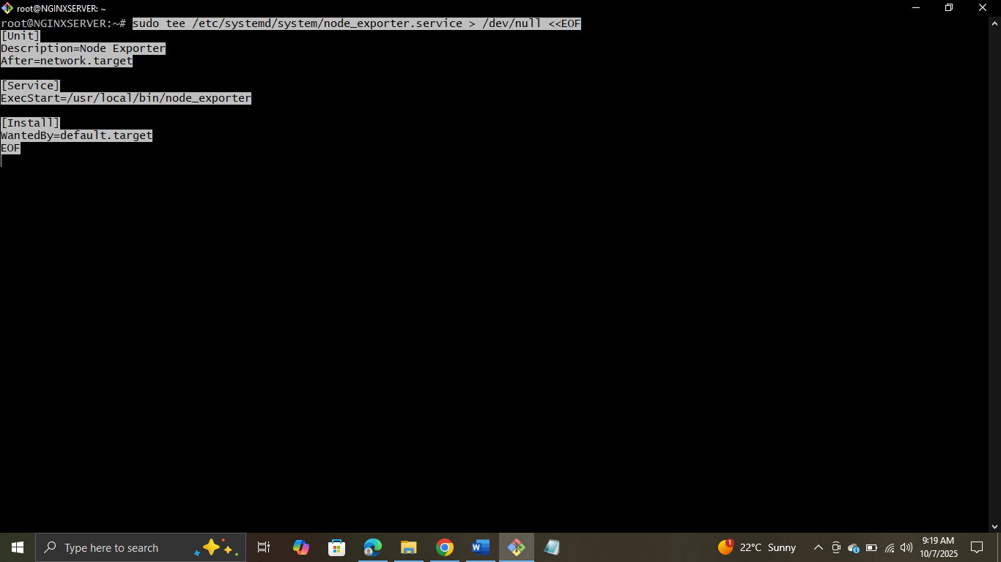

Relaoding, Enabling and Starting Node Exporter

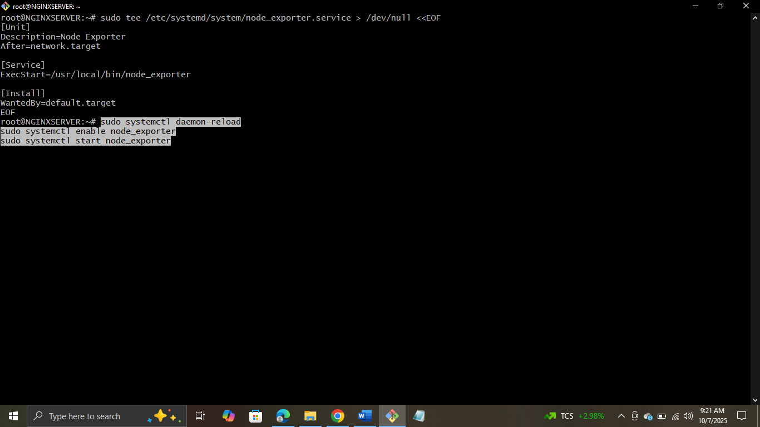

Verifying by taking Public IP

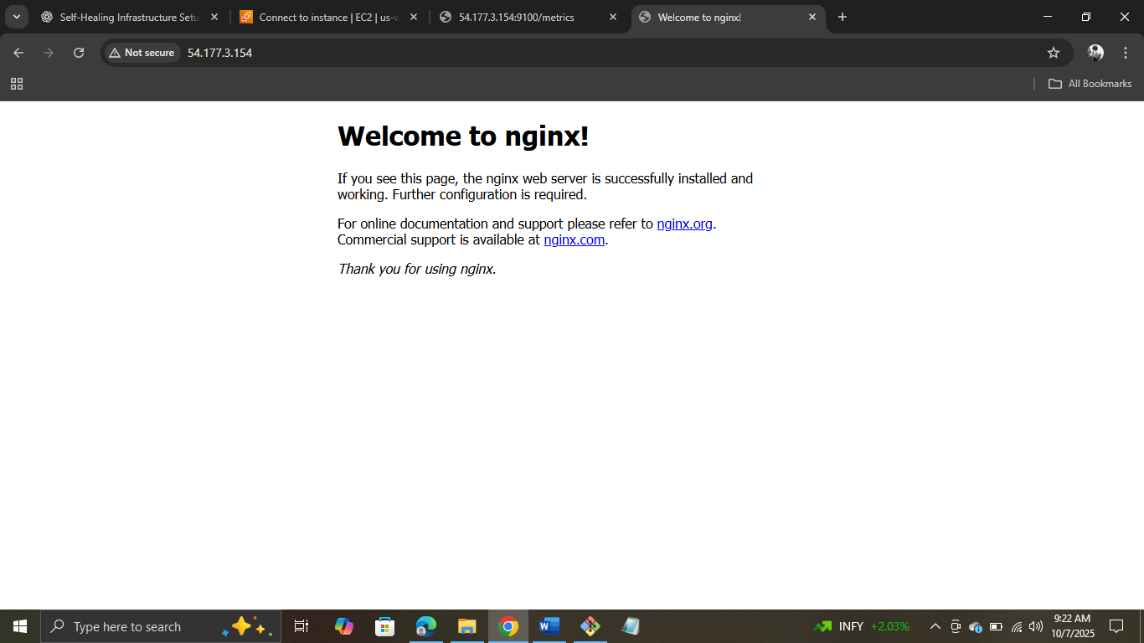

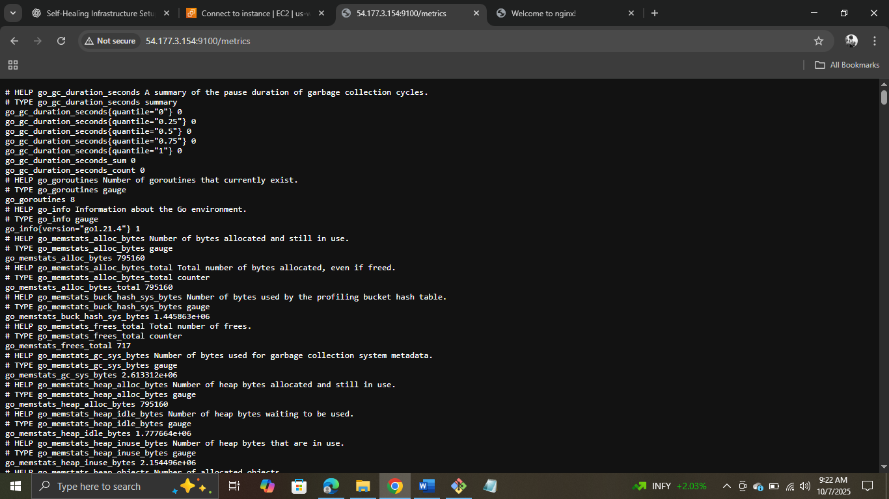

Step 3: Setting up Monitoring Server – Prometheus

Installing Prometheus

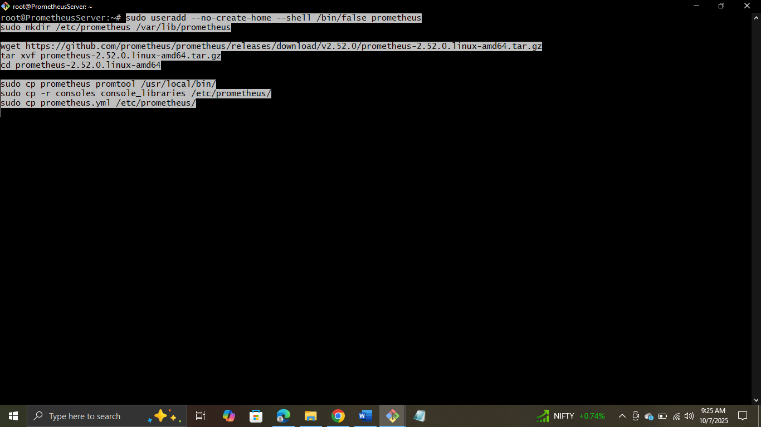

Editing Prometeheus Config – Opening the file

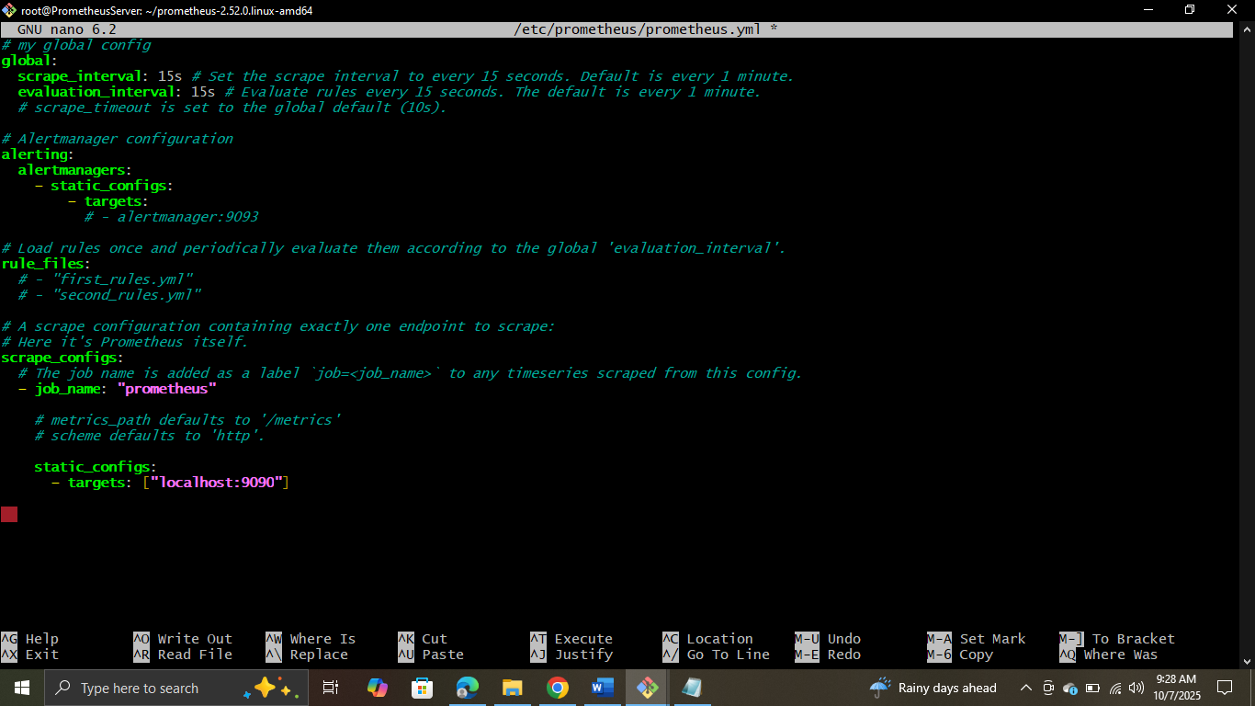

Adding the changes

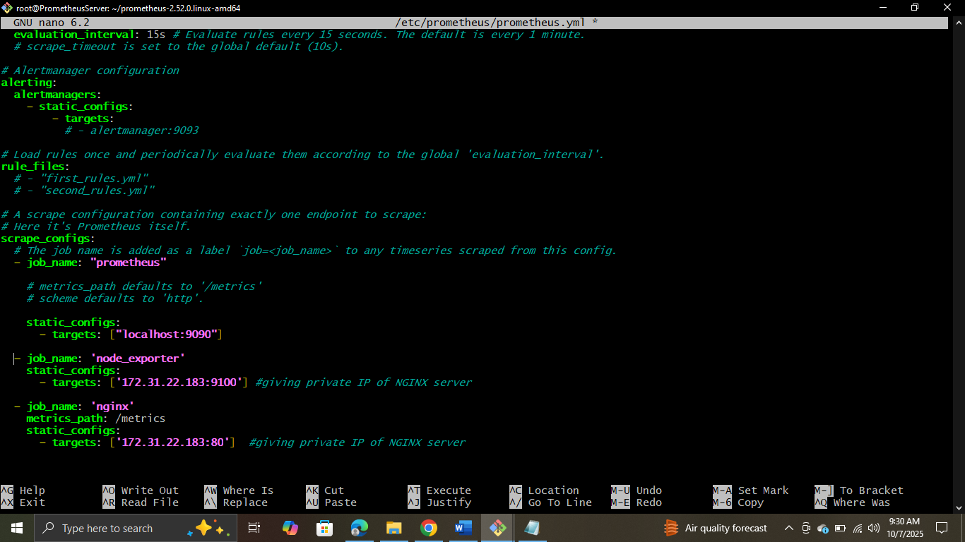

Creating Prometheus Service

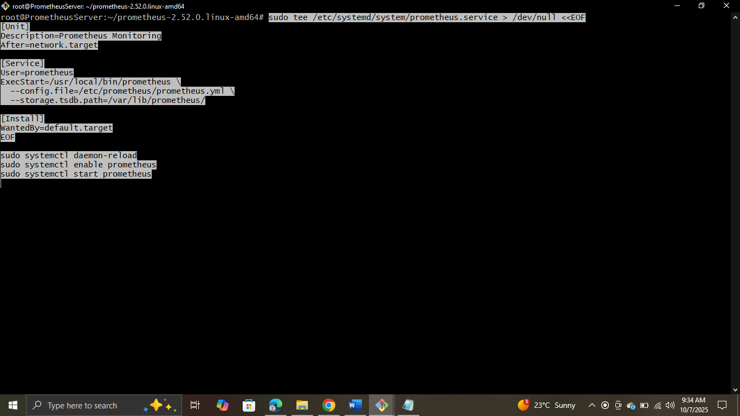

Relaoding, Enabling and Starting Prometheus

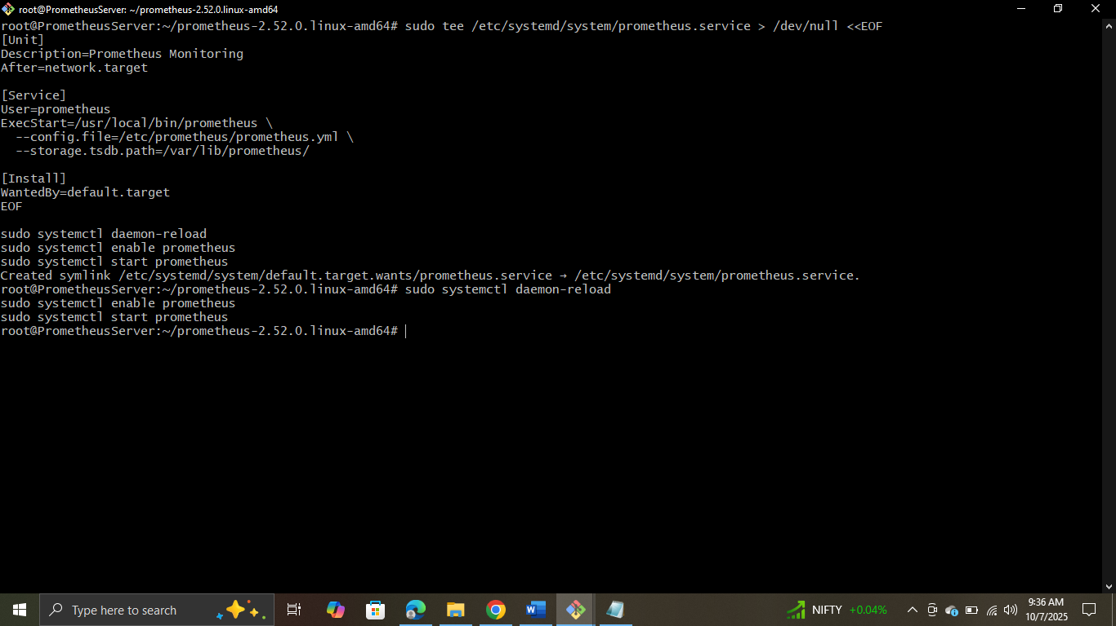

Verifying by taking Public IP: 9090

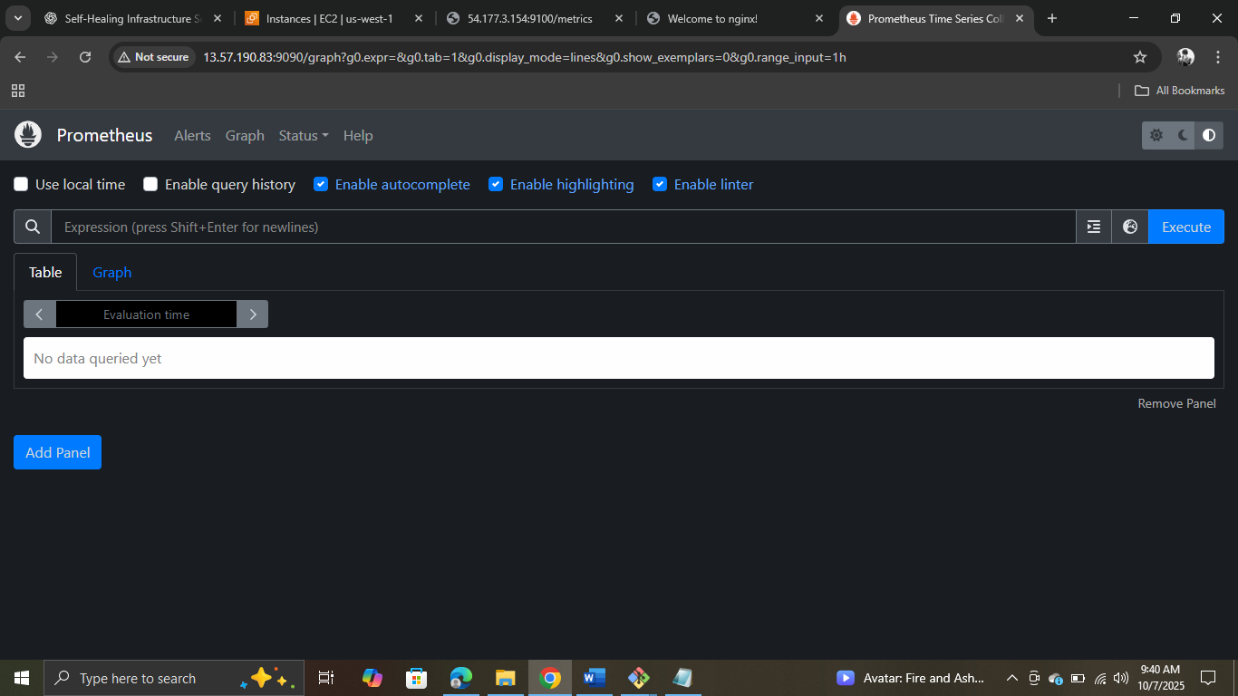

Step 4: Setting up Alertmanager on the same monitoring server

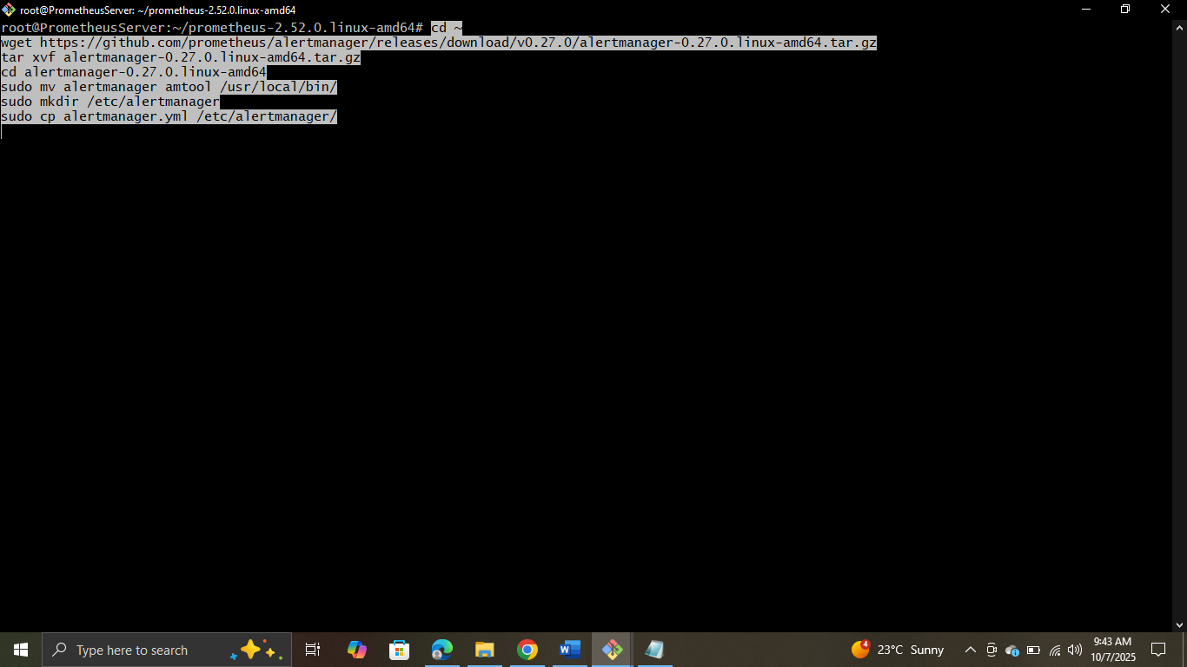

Configuring Alertmanager Webhook



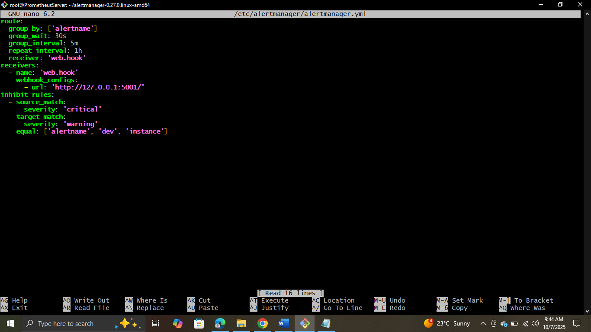

Adding Changes

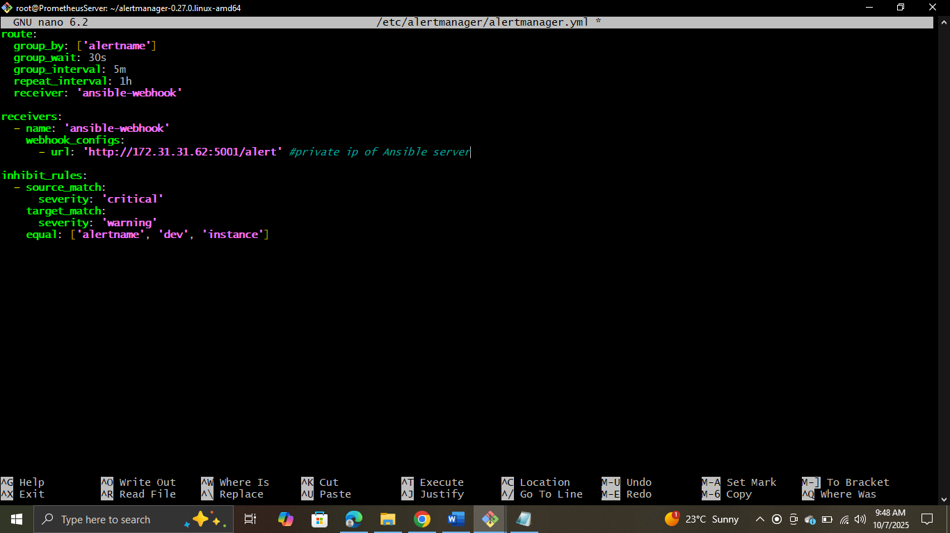

Step 5: Setting up Ansible Server and Installing Ansible and Flask

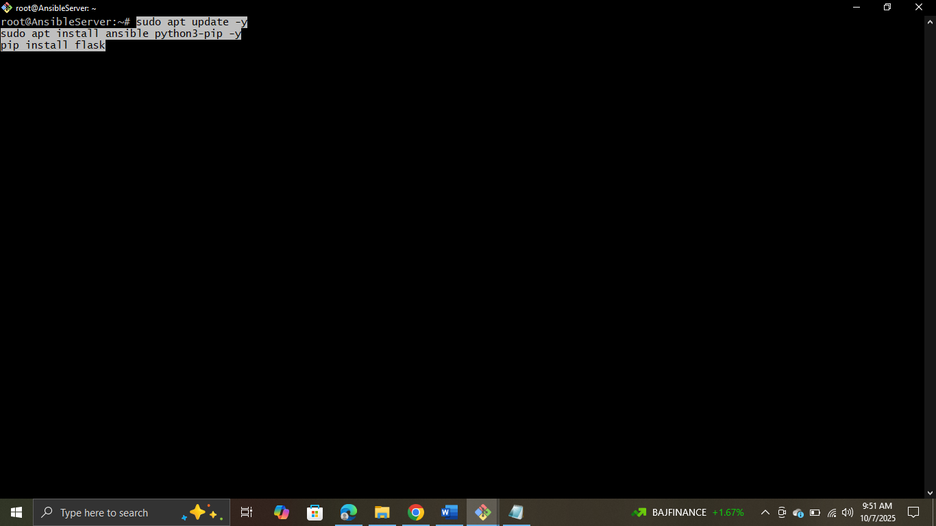

Creating Flask Webhook



Pasting the code (initially this file was empty)

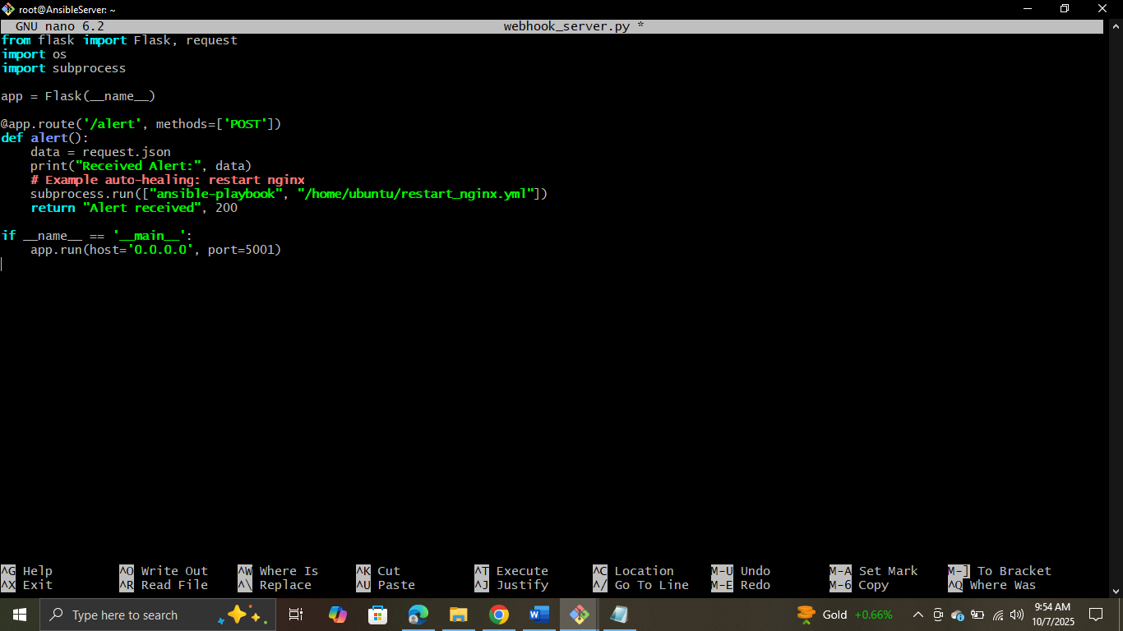

Running the code

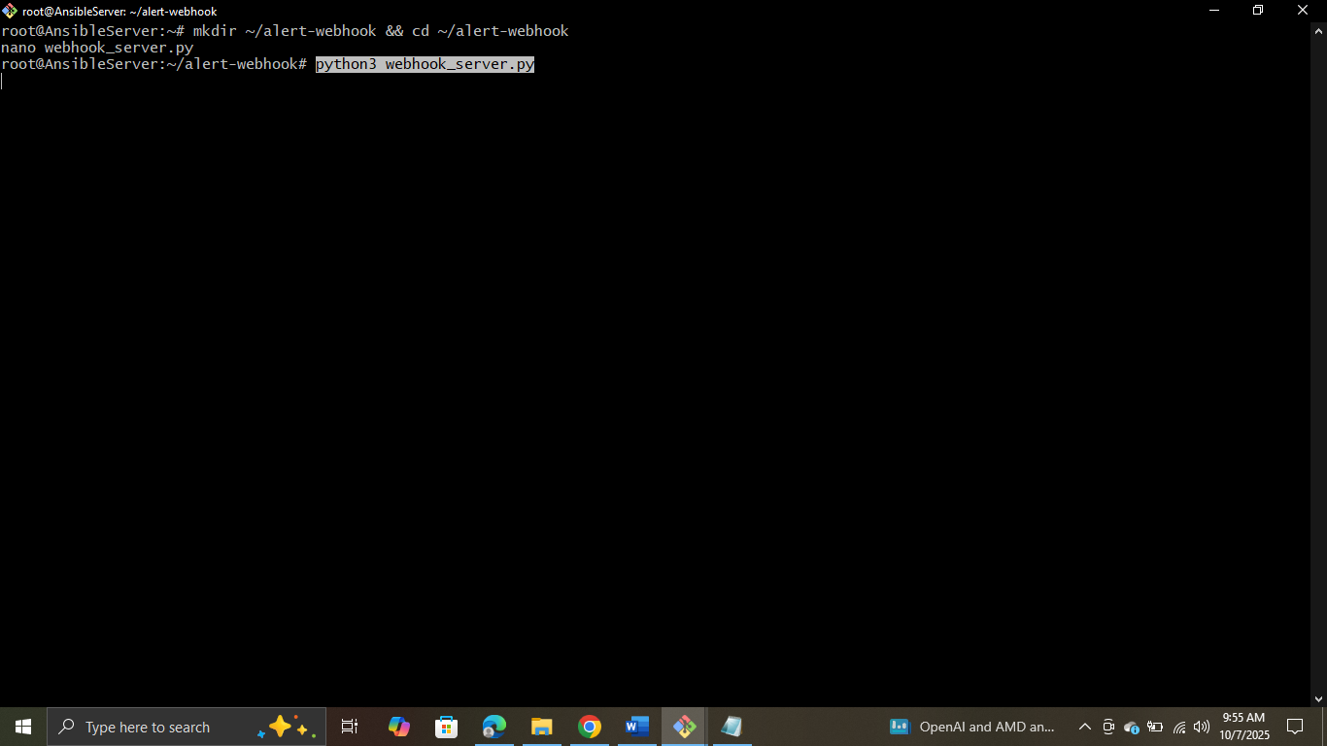

Creating Directory

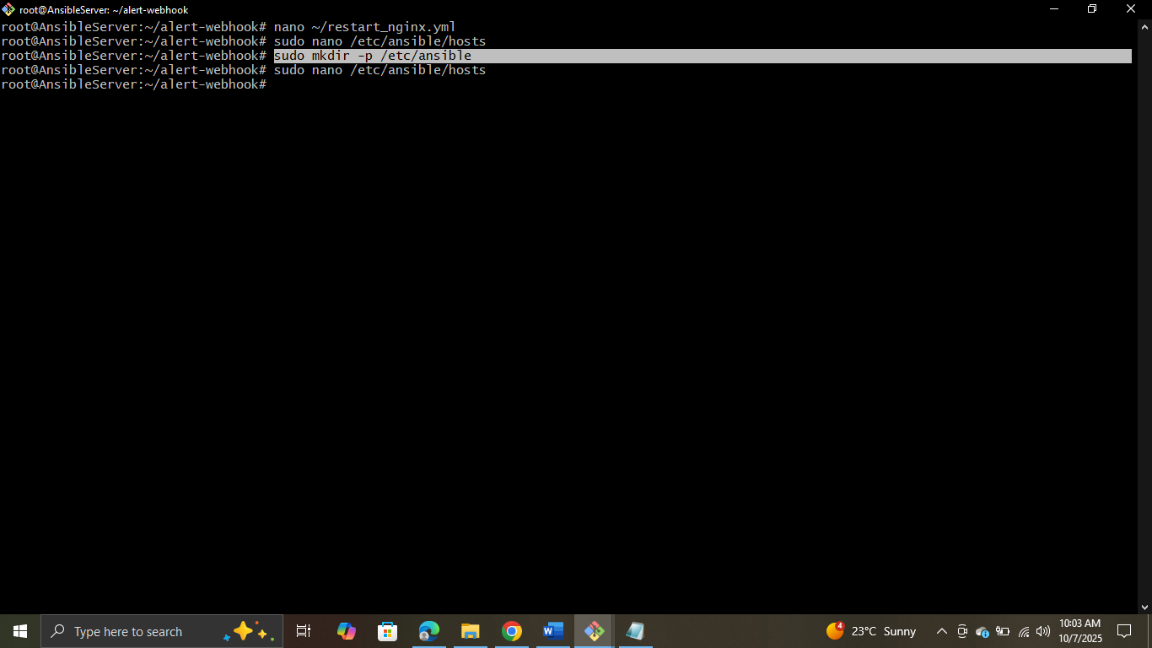

Creating Ansible Playbook



Pasting the code (Initially this file was Empty)

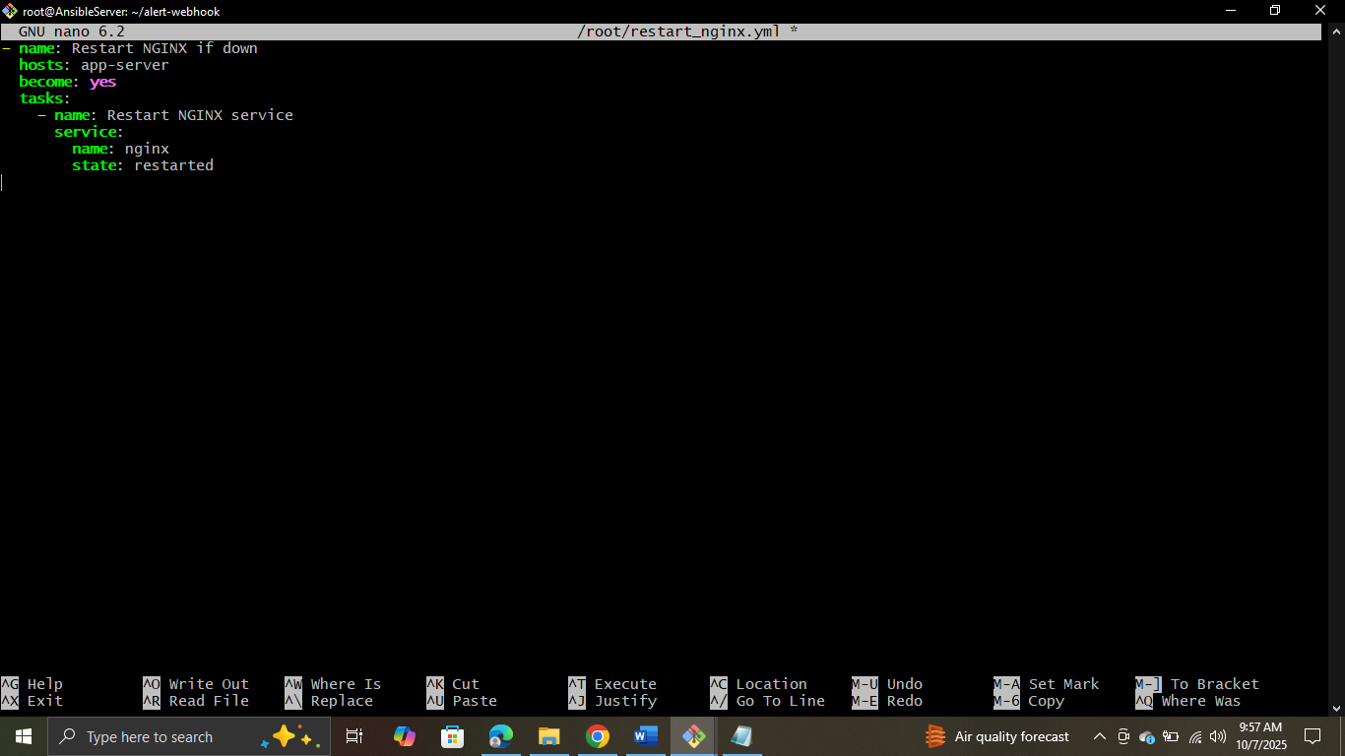

Configuring the Inventory

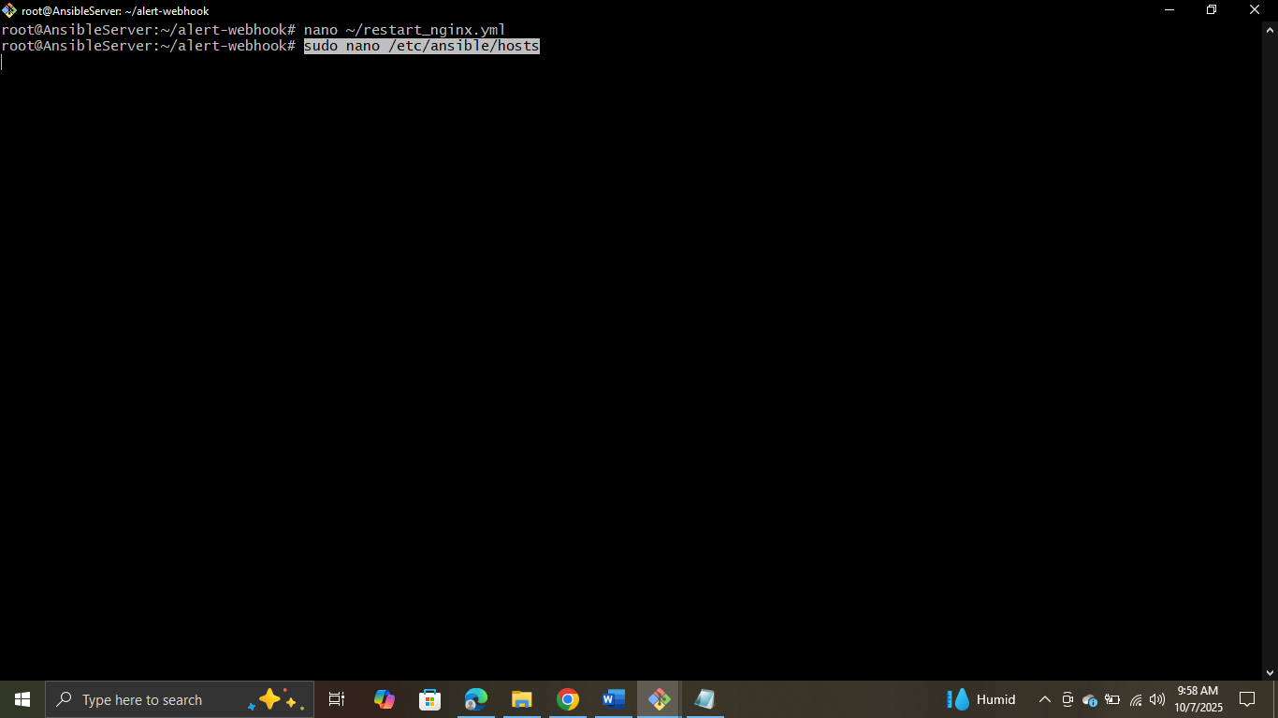

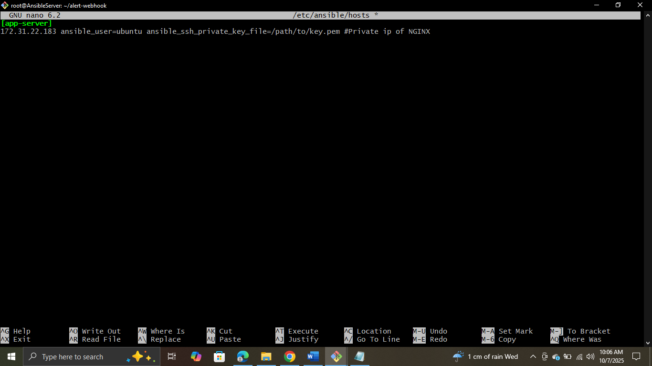

Testing the connection



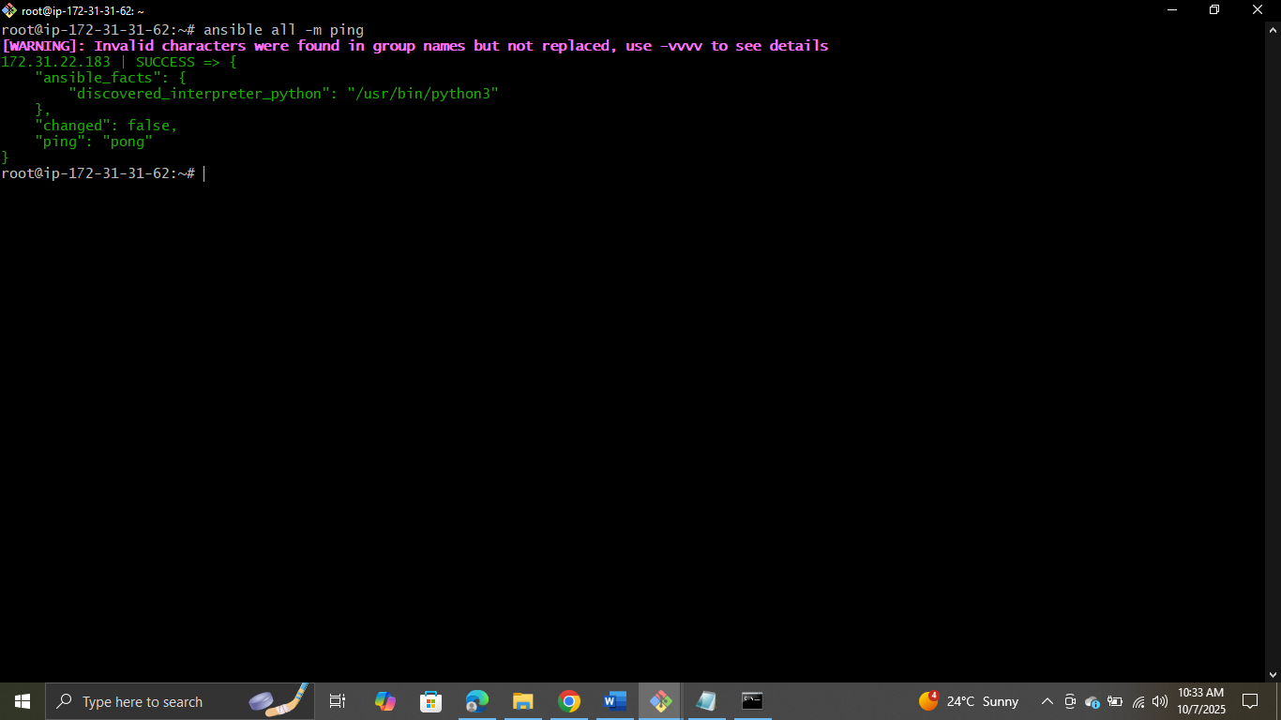

Creating Ansible Playbook

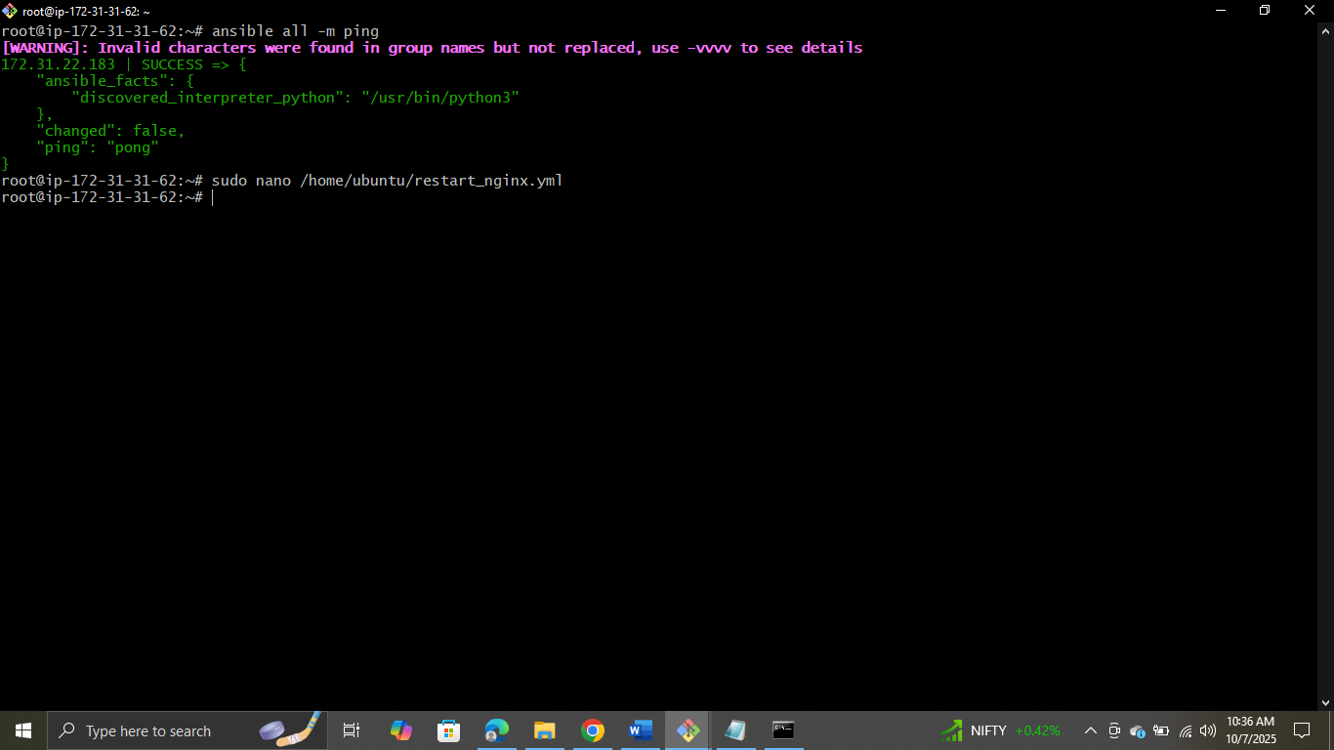

Adding the changes (File was empty)

